**1.Aim of the Microproject:**

The aim of a microproject using a seven-segment display is to learn how to control and display numerical or alphanumeric data using a microcontroller. It focuses on understanding the display's operation, designing the necessary circuits, and writing the code to drive the display efficiently. The project provides hands-on experience with components like resistors, transistors, and multiplexing techniques. It also teaches the use of common anode and common cathode configurations. Additionally, the project helps develop problem-solving and debugging skills, laying the groundwork for more advanced embedded systems and electronics applications.

**2.Proposed Methodology:**

The proposed methodology for the seven-segment display project begins with selecting a microcontroller, such as an Arduino or Raspberry Pi, and choosing a suitable seven-segment display (either common anode or common cathode). The next step involves designing the circuit, where the segments of the display are connected to the microcontroller through resistors to limit current and, if necessary, transistors for better control. The wiring should ensure each segment is properly connected to the microcontroller's digital output pins. If multiple digits are required, multiplexing techniques will be implemented to cycle through each digit and display the corresponding numbers or characters.

Once the hardware setup is complete, the programming phase involves writing code that controls the individual segments to form the desired numbers or characters. The microcontroller will send signals to the display's segments, lighting them up in specific patterns. The system will be tested to ensure accurate display output and efficient operation. Troubleshooting will be done to address any issues like incorrect segments lighting up, wiring faults, or programming errors. After successful testing, the system can be refined for power efficiency and reliability, ensuring it works effectively for its intended application.

**3.Brief Description:**

**3.1 Introduction:**

A seven-segment display is an electronic component used to display numeric digits (0-9) and, in some cases, alphabetic characters by illuminating specific segments. It consists of seven LEDs arranged in a figure-eight pattern, with each segment individually controlled to form different numbers or letters. Seven-segment displays are commonly used in devices like digital clocks, calculators, and measurement instruments due to their simplicity and ease of use. They are available in two configurations: common anode and common cathode, depending on how the segments are wired to the power source.

**3.2 Detailed Information:**

A seven-segment display is a simple electronic component used to display numerical digits (0-9) and some alphabetic characters by lighting up specific segments of the display. It consists of seven LEDs arranged in a figure-eight pattern, with each segment labeled from **a to g**. These segments are controlled individually to form different numbers or letters, making it ideal for devices like digital clocks, calculators, and measurement instruments. Seven-segment displays come in two types: **common anode** and **common cathode**, depending on how the segments are connected to the power source. In common anode displays, all anodes are connected together, and segments are activated by applying low voltage, while in common cathode displays, all cathodes are connected, and segments are activated by applying high voltage.

The primary use of a seven-segment display is to represent numbers, but it can also display a limited set of alphabetic characters. The display is controlled by a microcontroller, which sends signals to each segment to form the desired digit or character. When multiple digits are needed, multiplexing techniques are used to cycle through each digit rapidly, creating the illusion of simultaneous multi-digit display. These displays are energy-efficient, easy to interface with, and widely used in various applications such as digital clocks, counters, and measurement devices, though they have limitations in representing complex characters compared to other display technologies like LCD or OLED.

**3.3 Types of seven-segment display:**

Seven-segment displays come in different types based on their configuration and the way they are controlled. The main types are:

1. **Common Anode Seven-Segment Display**:
   1. In a common anode display, all the anodes (positive terminals) of the LEDs in the segments are connected together to a common pin. Each segment lights up when a low voltage is applied to its cathode (negative terminal). The display is turned on by sending a low signal to the corresponding segment pin.
   2. **Usage**: This configuration is typically used in circuits where the controlling device outputs a low signal to activate the display.
2. **Common Cathode Seven-Segment Display**:
   1. In a common cathode display, all the cathodes (negative terminals) of the LEDs are connected together to a common pin. Each segment lights up when a high voltage is applied to its anode (positive terminal). The display is turned on by sending a high signal to the corresponding segment pin.
   2. **Usage**: This is the most common type and is typically used in circuits where the controlling device outputs a high signal to activate the display.

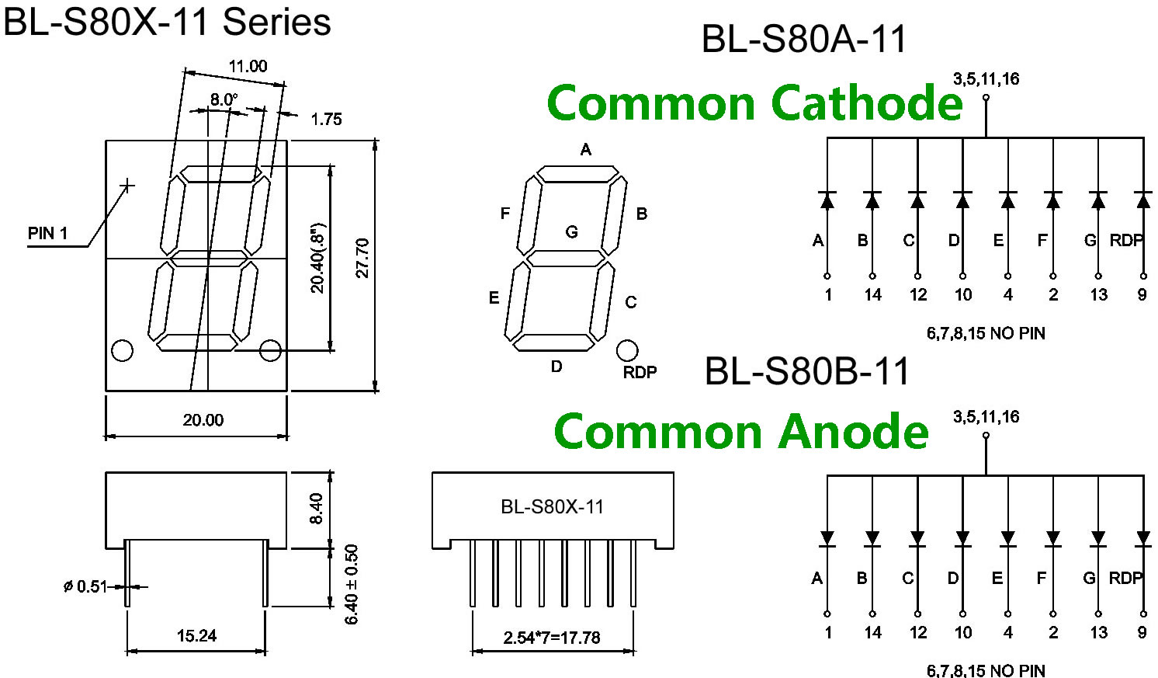

**Fig : Common Anode vs Common Cathode**

1. **Dynamic or Static Display:**
   1. **Dynamic Seven-Segment Display**: This type uses multiplexing to rapidly switch between multiple digits or characters, creating the illusion of simultaneous display. In a multi-digit display, only one digit is lit at a time, but it switches fast enough to appear as though all digits are lit at once.
   2. **Static Seven-Segment Display**: Each digit is driven individually, and all digits are lit at the same time. This type is less common due to its higher power consumption compared to dynamic displays.
2. **Alphanumeric Seven-Segment Display**:
   1. 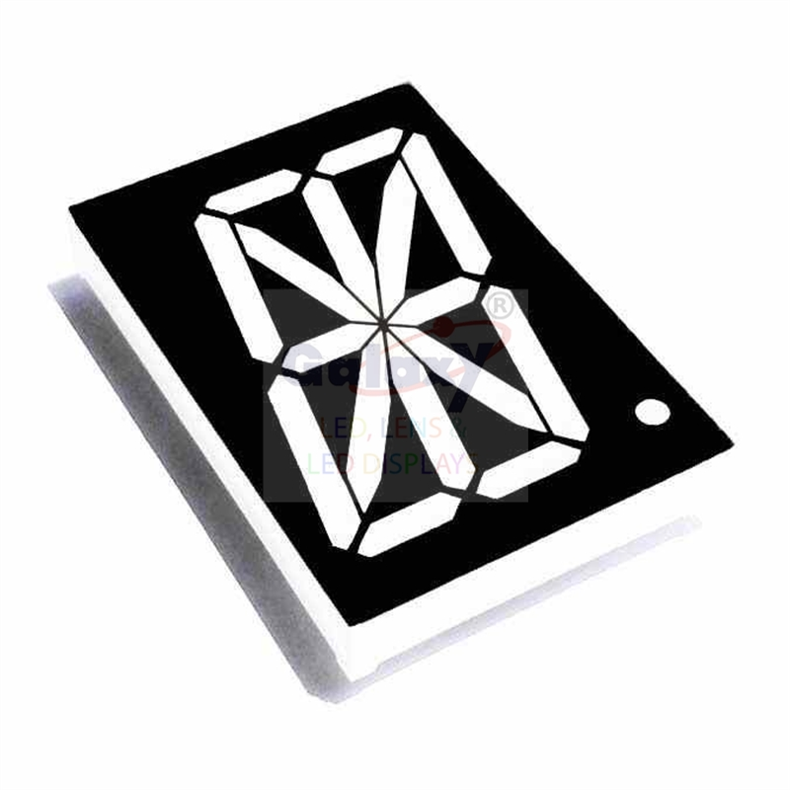While most seven-segment displays are used to show digits (0-9), **alphanumeric seven-segment displays** can represent both numbers and some letters (A-Z). However, due to the limited number of segments, only certain characters can be clearly displayed. These are often used in applications where limited text or symbols need to be shown, like simple electronic devices.

**Fig : Alphanumeric Seven-Segment Display**

**3.4 How Seven-Segment Display Work:**

**Working of Seven Segment Displays:**

The number 8 is displayed when the power is given to all the segments and if you disconnect the power for ‘g’, then it displays the number 0. In a seven-segment display, power (or voltage) at different pins can be applied at the same time, so we can form combinations of display numerical from 0 to 9. Since seven-segment displays cannot form alphabets like X and Z, so it cannot be used for the alphabet and they can be used only for displaying decimal numerical magnitudes. However, seven-segment displays can form alphabets A, B, C, D, E, and F, so they can also be used for representing each display unit is usually has a dot point (DP).  The display point could be located either towards the left or towards the right of the display pattern. This type of pattern can be used to display numerals from 0 to 9 and letters from to F hexadecimal digits.

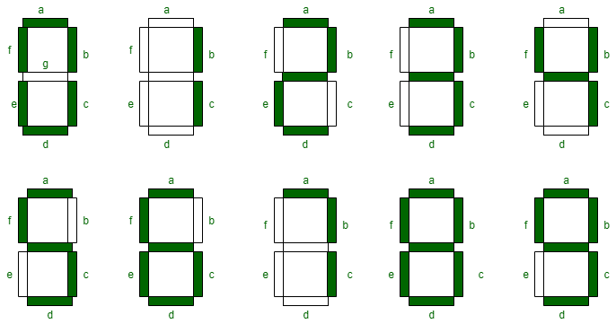

**Fig: Working of Seven Segment Displays**

**4. Advantages of Seven-Segment Display:**

1. Simplicity and Ease of Use
2. Low Power Consumption
3. Cost-Effective
4. Compact Size
5. High Visibility
6. Reliable and Durable
7. Versatility
8. **Disadvantages of Seven-Segment Display:**
9. Limited character display
10. Lack of flexibility
11. Flickering with multiplexing
12. Higher power consumption in multi-digit setups
13. Less versatility
14. Limited color options
15. Reduced readability at angles
16. Lower resolution
17. No backlight for visibility
18. Space limitations
19. Prone to damage
20. Complexity in dynamic displays

1. **Applications of Seven-Segment Display:**
2. Digital clocks and watches
3. Calculators
4. Measuring instruments (e.g., digital thermometers, voltmeters)
5. Digital counters (e.g., odometers, tally counters)
6. Microwave ovens
7. Gas pumps
8. Electronic meters (e.g., electricity, water meters)
9. Traffic signal displays
10. ATM machines
11. Scoreboards in sports
12. Home appliances (e.g., washing machines, air conditioners)
13. 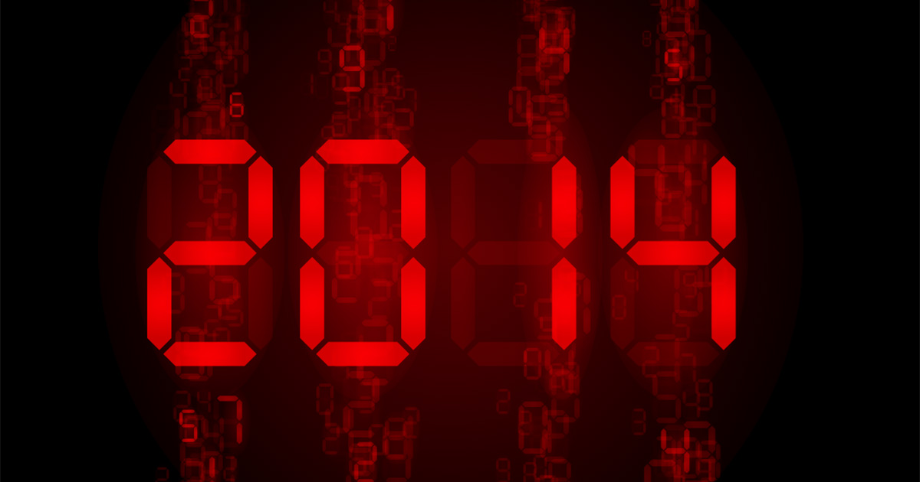Barcode scanners (for displaying output)

**Fig : Applications of Seven-Segment Display**

1. **Conclusion:**

In conclusion, seven-segment displays are widely used in various electronic devices due to their simplicity, cost-effectiveness, and ease of integration with microcontrollers. While they are ideal for displaying numeric data and some basic alphabetic characters, they have limitations in representing complex information or symbols. Despite these drawbacks, their low power consumption, high visibility, and reliability make them a preferred choice for applications like digital clocks, calculators, counters, and measuring instruments. Although more advanced display technologies exist, seven-segment displays continue to serve as an essential and practical component in many everyday devices.

1. **Reference:**

<https://www.geeksforgeeks.org/seven-segment-displays>

<https://www.watelectronics.com/7-segment-display>